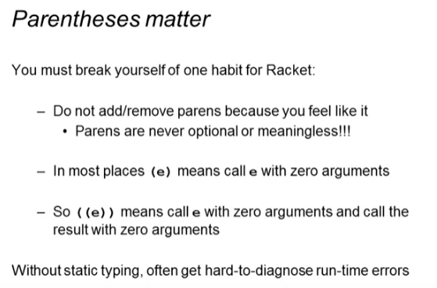

Correct version

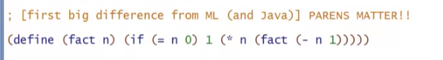

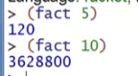

1st wrong version

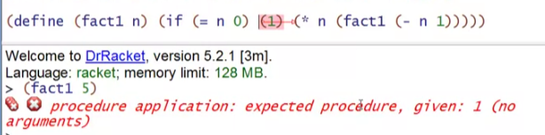

2nd wrong version

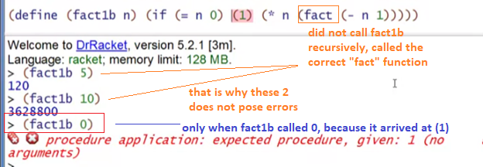

3rd wrong version

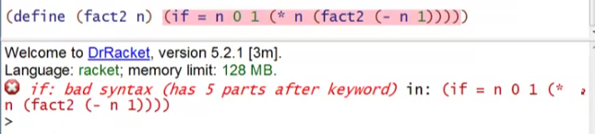

* Syntax error (all above wrong versions are runtime errors)

4th wrong version

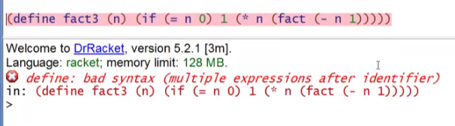

* Another syntax error

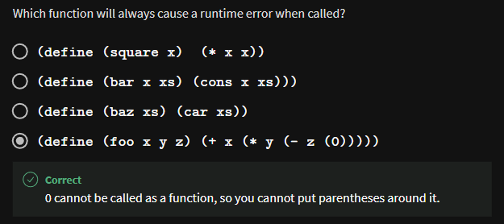

5th wrong version

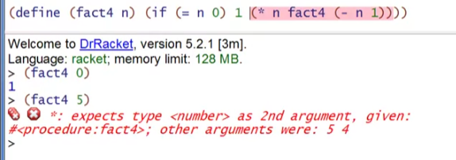

* Again, this will only trigger when the fact4 calls something that will fall in the false expression
  + Earlier example used to fall in true expression
* In ML, this will not type-check, but in Racket, it will. It will only cause runtime error when it falls to that branch

6th wrong version

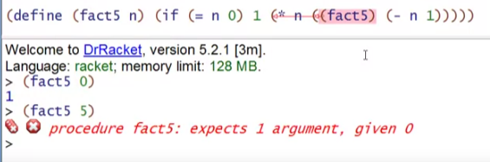

* Too many parenthesis
* Reads as no arguments

7th wrong version

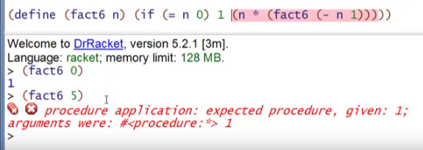

* Function calls in wrong order